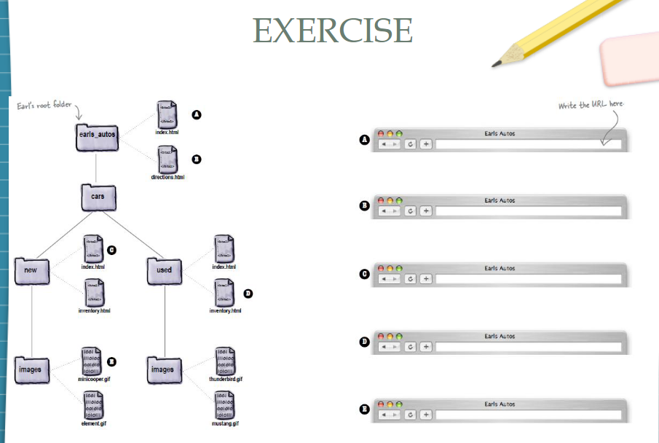
- /
- /directions.html
- /cars/new/
- /cars/used/inventory.html
- /cars/new/images/minicooper.gif

